Worksheet 5: The Sun & Moon
Question One
First quarter phase
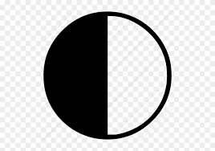
Third quarter phase

New Moon

Full Moon
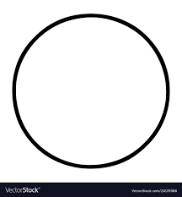
Question Two
The dark side and far side of the moon are synonyms. These terms refer to the lunar face we cannot see from the earth.
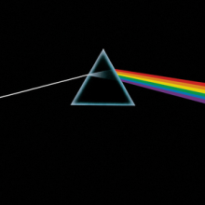
Question Three
Over time, the gravity of the earth has slowed down the moon’s rotation. This is called tidal locking. This implies that the time to orbit the earth and the time to spin on its axis are the same. So from earth, the moon always shows the same side.
Question Four
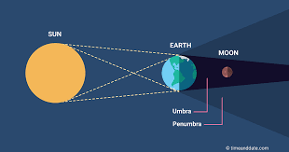
Question Five
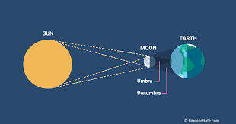
Question Six
Aurora is as a result of charged particles from the sun striking atoms in earth’s atmosphere causing electrons in the atoms to move to a higher-energy state. We are able to see them in the sky because they produce a light when the electrons drop back to a lower energy state. The different colors of Aurora depends on the wavelength of the light emitted. This is determined by specific atmospheric gas and its electrical state.
Question seven
Space weather refers to variable conditions on the sun and in space that can impact systems on earth and atmosphere. For humans, damaging particles from geomagnetic storms can hit astronauts and lead to health conditions. For satellites, charged particles from storms can damage electronics. For humans on earth, power and communications may be altered when magnetic fields on earth surface are induced by currents thus damaging structures like rails, roads, and power transmission lines, among others. Therefore, because of the threats of present in the atmosphere like geomagnetic storms, I would not consider going into space.

